Student’s name.
Instructor’s name.
Date of submission.
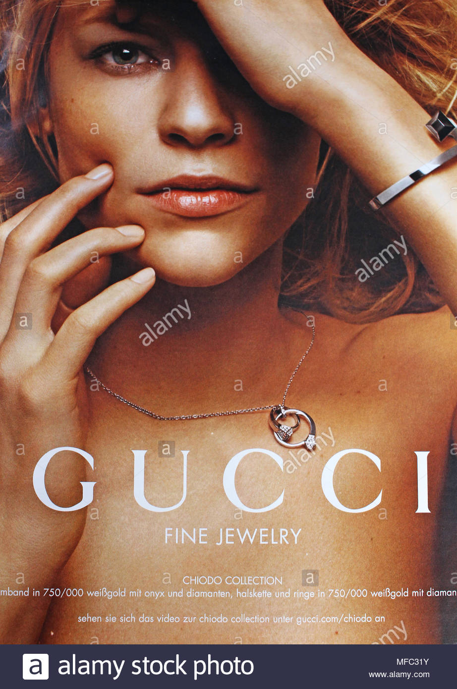
Gender bias in advertising has contributed significantly to social inequality through stereotyping in society. The advert is obtained from Alamy magazine, a fashion, beauty, and lifestyle publication in New York. It mainly targets young females who are considered to be more fashion enthusiasts. Since they are highly interested in trending fashion products, the advert sells jewelry made by one of the leading fashion brands, GUCCI. The women are considered to spend more on the items about fashion and lifestyle more compared to any other expenses. The ad shows that women are mainly concerned with how they look physically and not the issues that affect them in the society.
The stereotyping towards any gender limits the full realization of the potential that lies within human beings. According to Cortese & Anthony, (p26) the portrayal of women as only interested in their beauty and trending fashion indicates their lack of interest in the lead roles and other women's career development like their male counterparts. Individuals' abilities and unique talents do not count because they are overcrowded by the default stereotypes given to human beings of a certain gender. Human beings must be viewed solely based on their talents and not their gender or other personality classifications. The documentary "Miss Representation" depicts the hard experiences that women have to live within a society that has valued men and considers women only as subjects or instruments to be used at the man's cost in society. Therefore, the understanding of women is based on the standards set by society and the way they are presented in the media.
The media plays a major role in the promotion of stereotypes, as presented in the movie. Women are presented as inferior and emotional compared to men, which establishes a special image in the public's eyes. The film depicts women's issues as having their success being determined by their sexuality and beauty and not their professional skills or abilities. On the other hand, the movie presents the male in society as having to be aggressive and powerful to be considered successful in society. This wrong portrayal ends up limiting the abilities and discourages women from realizing beyond their capabilities. The media is a very important tool that shapes society in various ways, and any theme that is spearheaded in the media is likely to be consumed and practiced easily by the public.
Sexualization of women in the media brands them as instruments and tools for monetary or entertainment purposes, especially by their male counterparts. The images used generalize women as lovers of entertainment, fashion, and other secular world activities that they get distracted from their socio-political and economic opportunities. The movie indicates that such negative portrayals of women limit their aggressiveness in life as they have already settled to what is considered normal for them. They fail to seek a high leadership position because society has already believed they are incapable of handling delicate situations as they are indecisive and emotional. This misrepresentation has therefore denied women various opportunities that otherwise are supposed to be competitive between all genders.
The film gives various teenage girls and interviews from politicians and other professionals in different industries who give their accounts and experiences of how negative media propagates a poor breeding ground for women's success in society. The media is the best avenue to promote equity of both genders in all sectors to give equal leadership and corporate management opportunities. A corporation is using the advert to increase their product's sales using a false representation of women. Advertisements should be gender-conscious to ensure their content and message are not interpreted in any other way apart from the intended purpose.

Works cited.
Cortese, Anthony J. Provocateur: Images of women and minorities in advertising. Rowman & Littlefield, 2015.
Newsom, Jennifer Siebel. "Miss Representation [Documentary]." New York, NY: Virgil Films/Ro-Co films International/OWN Documentary Club (2011).

